Safety

Safety is the top priority in every lab. Every member in our team has been trained thoroughly before participating in any experiment. Our team not only strictly follows the general safety protocols but also comes up with protocols that is specific to our project in order to make sure that experiments proceed safely.

1. General Safety Protocols. 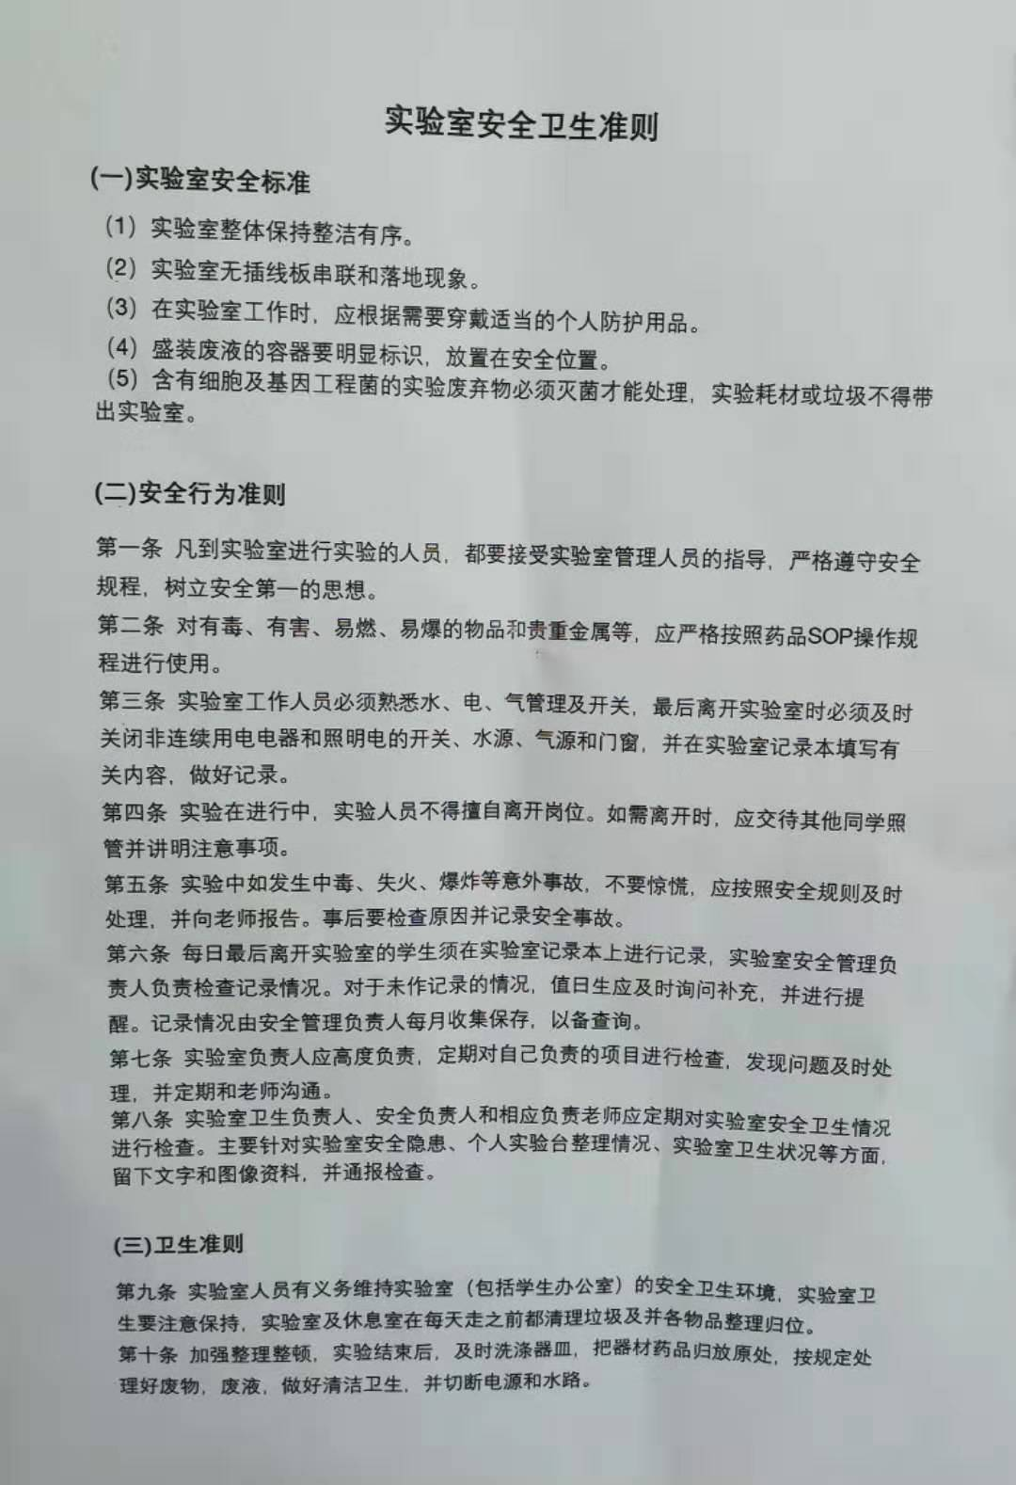

This is a general level 1 experiment safety procedure provided by Qing Huan University. As these instructions are the core of experimental safety, every team member will be tested according to these protocols before entering the lab.

2. Project’s safety protocols

In order to prevent safety issues that might raise in our project—Bio control of soft rot, we designed safety protocols specific to our pr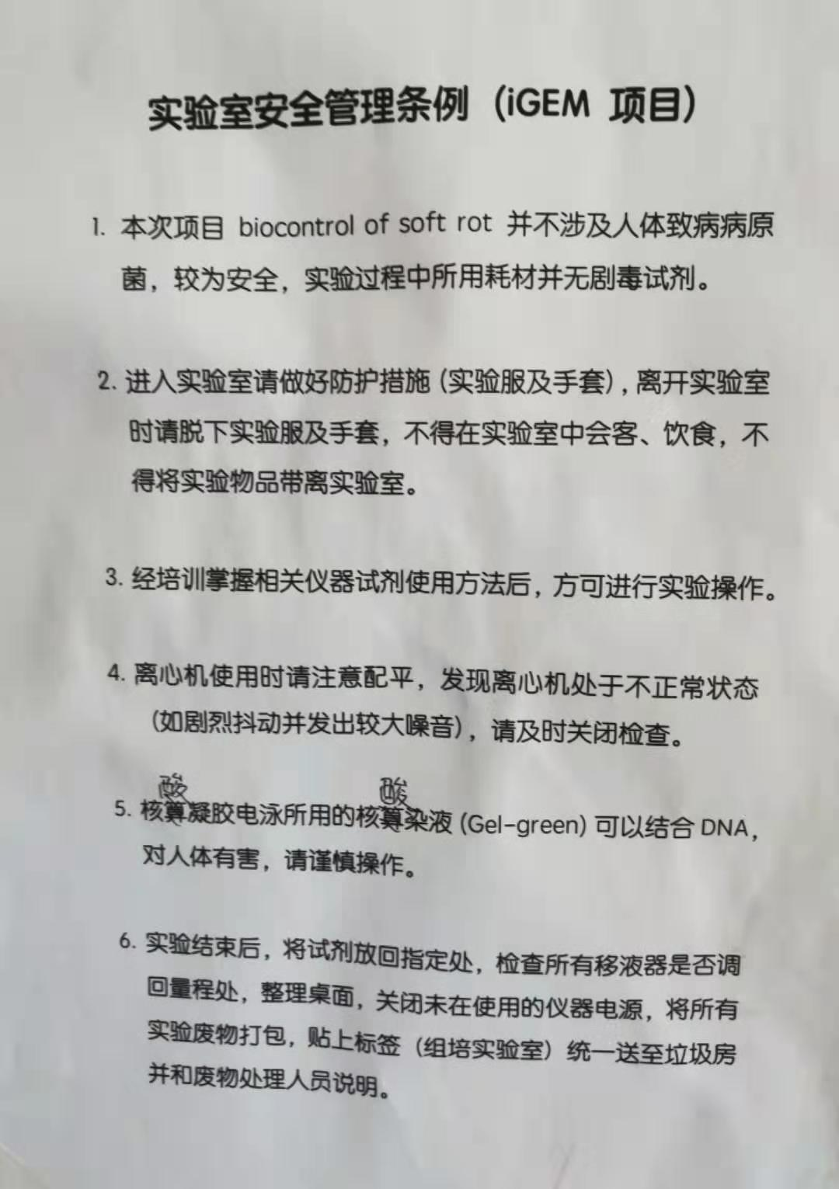oject.

All members should take special attention to procedure 5: Gel green used in electrophoresis can combine with DNA, which is harmful to human body.

During recycle, centrifuge is used frequently. Protocol 4 reminds our researchers to maintain balance when using the centrifuge. If centrifuge shakes intensely or emits loud noise, PD member in the lab should turn of the machine.

3. Cleaning the lab

To keep our lab clean, members are assign to clean the lab after every day’s experiment. Lab cleaners need to follow procedure in order to prevent solutions from contamination. Before leaving the lab, cleaners have to sign sheets checking the lab according to the protocol. 